
NOTICE of RACE

2012 IKA COURSE RACING SOUTH AMERICAN CHAMPIONSHIPS
15.11.2012 – 18.11.2012
To be held and organized by
Buzios Vela Clube, Buzios, RJ, Brasil
in co-operation with the
Associação Brasileira de Kitesurfing
and the
Confederação Brasileira de Vela e Motor

An International Kiteboarding Association sanctioned event

- RULES
    - The ISAF Racing Rules of Sailing (RRS), including Appendix BB (January 2012 Version)
    - The IKA Class Rules.
    - The IKA Championship Rules.
    - No National Authority prescriptions will apply.
    - The IKA Point System.
    - The IKA Code of Conduct.
  - If there is a conflict between the Notice of Race and the Sailing Instructions (SI’s), the SI’s shall take precedence.
  - If there is a conflict between languages, the English text will take precedence.

- ADVERTISING
  - ISAF Regulation 20 - Advertising Code- shall apply.
  - Competitors may be required to carry advertising for event sponsors – both on their kiteboards, and on a lycra vest if supplied by the organiser.

- VENUE
The event will be based at the Búzios Vela Clube (Rua Maurício Dutra 303, Armação de Búzios, RJ) at the Manguinhos Beach. The race area is the bay in front of the Club, see Attachment 1. For more information visit: www.buziosvelaclube.com.br , or contact: bbllmm@hotmail.com
  - Conditions to be expected – winds 15-25 knots; water conditions: flat till up to 0.5 m waves; water temperature 20 degree celsius; air temperature 27/30 degrees Celsius

- CLASSES AND DIVISIONS
  - The participating classes and divisions shall be:
Kite racing – Men, Women, Youth Men, Youth Women, Masters, Grand Masters.
  - Age Divisions: See ATTACHMENT 3, IKA Championship Rules.
    - Youth men and women shall race together.
  - The event scores 200 points towards the IKA course racing world rankings

- ELIGIBILITY & ENTRY
  - All entries shall meet the requirements of ISAF Regulation 19 - Eligibility Code.
  - Competitors shall be members of a National Kiteboarding Class Association, or of the relevant International Class Association, and their current year membership fees shall have been fully paid. National Associations shall be paid up members of the IKA.
  - Individual Membership formalities can be completed on site for competitors without national class association.
  - Competitors shall provide the following documentation prior to completing registration formalities on site:
- Original Entry Form (ATTACHMENT 2)
- Proof of Entry Fee payment
- Evidence of national membership
- Evidence of valid third party insurance – minimum 1 million reais
- Proof of age
- Parental/legal Guardian Assent - for those under age of 18
- Medical Treatment Permission - for those under age of 18 or on their parents medical insurance policy
  - Coaches and team support personnel shall provide the following documentation prior to completing registration formalities on site:
        - Original Coach Entry Form
        - Proof of Coach Entry Fee payment
        - Boat Driving Licence
        - Evidence of valid third party insurance for drivers of coach boats – minimum 5 million reais

- FEES
  - The required fees are as follows:
Youth: US$65
Men/Women: US$ 80
Coaches and team support personnel: US$ 15
  - For entries made after Monday 6th November a US$ 10 surcharge will apply.
  - Fees, in Reais, may be sent by bank transfer, in the name of Buzios Vela Clube - To:
Banco SANTANDER - Agência 2247; Conta Corrente: 13.000.5798
CNPJ 03.392.744/0001-97
  - Sailors may pay upon registration but must send in their registration forms by Monday 6th November, the surcharge will apply to registration forms received beyond this date. Entry fees paid upon registration shall be paid in cash – US$, Euro or Real

- SCHEDULE
Date | Time | Event
November 14 | 1500-1900 | Registration
November 15 | 0900-1100  1100  1200 | Registration  Opening Ceremony (mandatory) and skippers meeting  First possible warning signal
November 16 | 0900  1000 | Skippers meeting  First possible warning signal
November 17 | 0900  1000 | Skippers meeting  First possible warning signal
November 18 | 0900  1000  1500  1600 | Skippers meeting  First possible warning signal  Last possible warning signal  Prize giving

- EQUIPMENT & EQUIPMENT INSPECTION
  - It is the responsibility of each competitor to ensure that his/her board and equipment conforms to its Class Rules.
  - Competitors shall bring their own equipment.
  - Competitors shall ensure that a completed “Equipment Registration Form” is returned to the Race Office before the start of the first race.
  - A board or equipment may be inspected at any time for compliance with the class rules and sailing instructions.
  - Substitution of damaged or lost equipment will not be allowed unless approved by the Race Committee. Requests for substitution shall be made to the Race Committee at the first reasonable opportunity.
- IDENTIFICATION
  - Every competitor is required to wear the official event lycra with his personal identification number whenever competing

- BUOYANCY
  - If personal buoyancy is prescribed every competitor and support boat crewmember shall wear, above the waist, a jacket harness or vest with a minimum buoyancy of 4kg un-inflated in fresh water. The buoyancy shall be tested with a ferrous metal weight of 4kg, which shall remain supported for a minimum of 5 minutes.
  - Personal buoyancy is mandatory for all competitors under 18 years of age.

- OFFICIAL NOTICE BOARD
  - The official notice board is located on the club´s race office window.

- SAILING INSTRUCTIONS
  - The event SIs' will be available at registration and will be published on the Club´s web site.
  - Alterations to the SIs shall be approved by the Class Representative.
- COURSES
  - The courses will be windward/leeward, with or without offset-marks and with or without gates, or box slalom courses.
  - Alternate courses may be used during the regatta depending on wind and weather conditions.

- SCORING
  - The low point system of Appendix A shall apply, except that the winner of a race shall receive 0.7 points.

- PENALTY SYSTEM
  - A penalty system according to Appendix BB will be used.
  - The penalty will be a 360-turn penalty under rule 44.2 of Appendix BB
  - Competitors can chose to take a scoring penalty (10%) according to rule 44.3 of Appendix BB.

- Protest Committee
  - A Protest committee will be appointed in accordance with the RRS 91.

- SUPPORT BOATS
  - Support boats shall clearly display their national 3 letter country code in black on a white background, either on a flag of a minimum of 50cm x 40cm in size or on the cover of their outboard engine.

- STORAGE OF EQUIPMENT
  - On completion of registration and continuing until the end of the regatta, when ashore (other than when launching and retrieving), all equipment shall be kept in their assigned places inside the club or on the beach in front of the club. Access to equipment in the storage area during hours of darkness may be restricted.
- MEDALS AND PRIZES
  - Medals or trophies shall be awarded to the first three competitors of the open mens and womens divisions depending on entry numbers. Prizes to be awarded in each properly constituted division may be posted on the official notice board after the close of registration.

- DISCLAIMER OF LIABILITY
  - Competitors take part in all races at their own risk. The LOA, IKA, ISAF or any of their officials or representatives or the sponsors or their officials or representatives are not responsible, under any circumstances, for any damage, loss or injury either ashore or on the water either to persons or equipment, which may result.
  - Participation in this event, supporting events and in each race in them is at the sole discretion of the sailor and at his/her own risk. Notice is drawn to RRS 4.

- INSURANCE
  - Competitors shall possess valid third party liability insurance with a minimum cover of 1 million reais.
  - Coach and support boat drivers shall also have a valid third party liability insurance with a minimum cover of 5 million reais, besides valid appropriate licence to drive boats.

- TELEVISION AND MEDIA
  - In registering for the event, competitors automatically grant to the Organising Authority the right in perpetuity to make, use and show from time to time at their discretion, any motion pictures, still pictures and live, taped or filmed television and other reproduction of them, taken during the period of the event, for the said Championship as defined in the Notice of Race and Sailing Instructions in which he/she participates without compensation.

- OFFICIAL CEREMONIES
  - Attendance at the Opening Ceremony, Prize Giving and Closing Ceremony is mandatory.
  - The organiser reserves the right to refuse entry to those whose standard of attire is not commensurate with the occasion.
- DRUG TESTING
  - Competitors are reminded of the ISAF rules and regulations concerning the use of banned methods and substances. Drug testing may take place during the event.

- INFORMATION
For further information contact: bbllmm@hotmail.com

ATTACHMENT 1

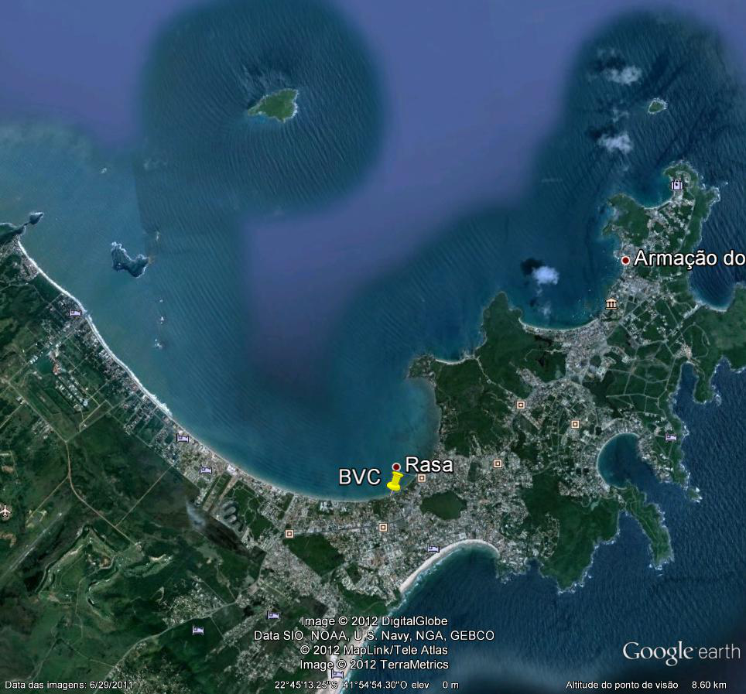

ATTACHMENT 2

1° KITE RACING SOUTH AMERICAN CHAMPIONSHIP 2012
BÚZIOS VELA CLUBE

Regatta Entry Form

NAME: ___________________________________________________________________________

CATEGORY: __________________________Date of Birth: _________________________________
CLUB: ____________________________________________________________________________

ADDRESS: ________________________________________________________________________

POSTAL CODE: ___________________CITY: ____________________________________________

COUNTRY: ___________________________________

TEL: _________________________________________

EMAIL: ___________________________________________________________________________

AGREEMENT
I agree to be governed by the ISAF Racing Rules, the relevant Class Rules, the Notice of Race and the Sailing Instructions and I accept the penalties assessed under these rules and such other action as may be taken hereunder, subject to such appeal and review procedures as are provided herein, as the final determination of any matter arising under these rules and I agree not to report to any court or tribunal not provided here in with respect to such determination.
I accept that under RRS Fundamental Rule 4, it is my sole responsibility to decide whether or not to start or to continue to race or compete, and I agree not to report to any court or tribunal with respect to such a decision and its consequences.

Competitor's Signature: ______________________________________________________________

Parent´s or Guardian´s Signature: _____________________________________________________

Date:_____________________________

Competitors participate in the event entirely at their own risk, see RRS 4 - Decision to Race. The organizing authority or any of their officials or representatives or the sponsors or their officials or representatives will not accept any liability for material damage or personal injury or death sustained in conjunction with or prior to, during or after the event.

Attachment 3
Championship Rules 2012 – Course Racing
- Number of Races; Time Limits and Target Times; Wind Speeds
  - Number of Races
    - No more than 6 races per day per fleet shall be raced
    - No more than 3 races shall be raced back to back
  - Time Limits and Target Times (may be adjusted depending on conditions)
    - The time limit for the first racer to reach the first mark is 10 minutes
    - The time limit for the first racer to finish the course is 40 minutes
    - The target time for the first finisher is 15 minutes
    - The finish time limit shall be 10 minutes depending on fleet and conditions
    - Finish times shall be taken separately for each division
  - Wind Speeds
    - If the wind speed is less than 6 knots average in the starting area during the preparation signal and the starting signal, or the wind speed is dropping below 5 knots at any time during the last minute prior to the starting signal, the start shall be postponed and a new starting sequence initiated as soon as the wind strength is sufficient.
    - Wind speeds shall be taken from a drifting boat from approximately 2 meters above the sea surface. If a drifting boat is not available, the current shall be measured and calculated to establish the minimum wind speed requirement.
    - If possible, the wind speed shall be measured also on the windward mark during the times when 1.c.i applies
    - The race shall be abandoned if a notable number of competitors is capsized due to insufficient wind. This decision, taken by the race officer, is not appealable and not a reason for a request for redress.
- Equipment
All equipment used in international course racing events must be included on the relevant IKA production equipment list for boards and kites on the first day of the event latest.
It is each competitors sole responsibility that the equipment on which he is racing complies with the class rules.
Attention is drawn to the IKA class rules in their latest version.
  - A production board is a board that has been registered with the IKA and fits into the new box rule. This means it must not exceed certain measurements (70 cm wide and 190cm long), and it needs to be built in a series production process (which means that all boards are close to identical), of at least 30 pieces per model
  - The same applies to kites, they have to be production manufactured in a series production process of at least 50 pieces per model (for sizes 10m and bigger) and 15 pieces for smaller kites.
  - Only three kites are to be registered for an event. Only one board will be allowed to be used at an event.
  - When registering for an international event (on site at the registration day) the board and kites to be used during the competition must be registered. Equipment inspection will take place randomly during the competition days, however it is the responsibility of every competitor to have a look if one of his competitors is using equipment that he either did not register or which is not production. In this he might protest the other competitor.
- Fleet or Group Racing
  - Where there are 60 or fewer competitors registered, they shall race together in one fleet
  - Where there are between 61 and 100 competitors entered, the class representative shall decide whether they shall race in one fleet or if the fleet shall be separated by division
  - Where there are more than 100 competitors registered in one division, they shall race in groups in a qualifying series followed by a final series
  - For group racing, the competitors of each division shall be divided into two, three or four groups of equal ability
  - The decision of the class representative is final
- Courses
  - Recommended courses are:
    - Windward/Leeward
    - Windward/Leeward with Offset-Mark
    - Windward/Leeward with Leeward Gates
And their variations (including trapezoid course configurations)
- The course area is defined as an area extending 75 meters beyond the course including the starting line and its extensions
Recalls
- Recalls
Races shall only use general recalls. The black flag rule is enforced for every start
Scoring and Discards
  - Scoring shall be in accordance with Appendix BB – with the winner of a race taking 0.7 points instead of 1 point.
- Discards shall be as follows:
1-3 races: 0 discards
4-6 races: 1 discard
7-10 races: 2 discards
11-15 races: 3 discards
16 and more races: 4 discards
Age Division
  - Youth: under 18 years of age in the year of the competition
  - Senior: open to competitors of all ages
  - Master: 35+ years of age in the year of the competition
  - Grand Master: 45+ years of age in the year of the competition
- A minimum of 5 entries in an age division is required to constitute this division.
- A competitor must not be older than the maximum age limit in the relevant age division by December 31st in the year of competition.
- A competitor must have reached the minimum age limit in the relevant age division by December 31st before the year of competition.

